For each question from 16 to 20, chodse the word(s) closest in meaning to the  
underlined word(s). Shade your answer (1, 2, 3 or 4) on the Optical Answer Sheet  
(OAS). . (5 marks)

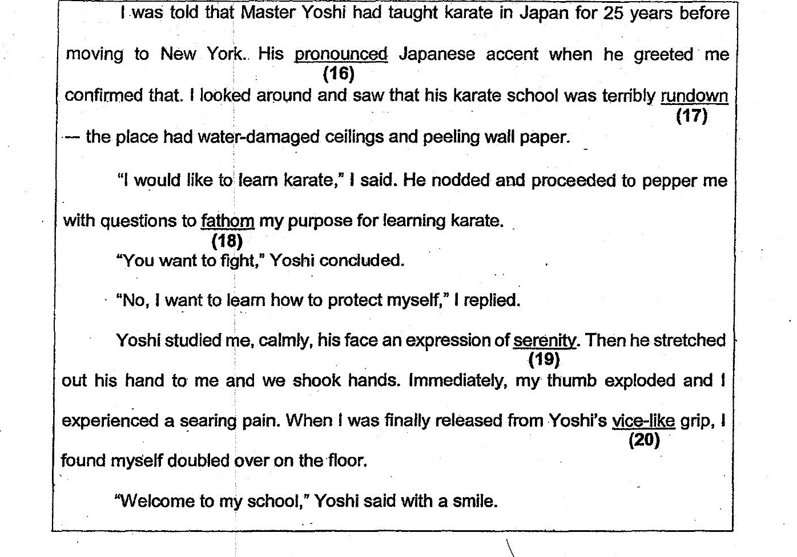

16, {1} loud  
(2) deep  
(3) — harsh  
(4) — distinct

17. (1) rugged -  
(2) ghastly :  
(3) shabby  
(4) _ slipshod :

18. (1) gauge  
(2) interpret  
(3) recognise  
(4) understand